UNITED STATES
SECURITIES AND EXCHANGE COMMISSION
Washington, D.C. 20549

SCHEDULE 14A
Proxy Statement Pursuant to Section 14(a) of the
Securities Exchange Act of 1934
(Amendment No. )

Filed by the Registrant ☑
Filed by a Party other than the Registrant ☐
Check the appropriate box:

☐ | Preliminary Proxy Statement

☐ | Confidential, For Use of the Commission Only (as permitted by Rule 14a-6(e)(2))

☐ | Definitive Proxy Statement

☑ | Definitive Additional Materials

☐ | Soliciting Material under § 240.14a-12
Analog Devices, Inc.
(Name of Registrant as Specified in Its Charter)
(Name of Person(s) Filing Proxy Statement, if Other Than the Registrant)
Payment of Filing Fee (Check all boxes that apply):

☑ | No fee required

☐ | Fee paid previously with preliminary materials

☐ | Fee computed on table in exhibit required by Item 25(b) per Exchange Act Rules 14a-6(i)(1) and 0-11

Explanatory Note
Analog Devices, Inc. (the Company) is filing a copy of a slide presentation that was sent to shareholders on February 29, 2024 relating to the Institutional Shareholder Services Proxy Analysis & Benchmark Policy Voting Recommendations on the Companys 2024 proxy statement.


ADI SHAREHOLDER PRESENTATION Spring 2024

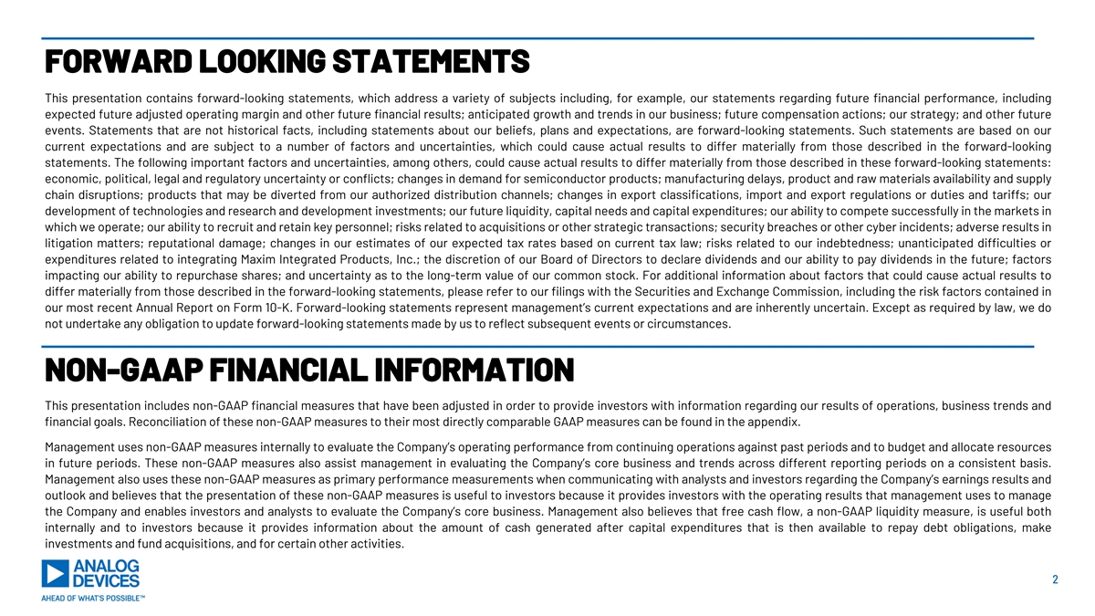
FORWARD LOOKING STATEMENTS This presentation contains forward-looking statements, which address a variety of subjects including, for example, our statements regarding future financial performance, including expected future adjusted operating margin and other future financial results; anticipated growth and trends in our business; future compensation actions; our strategy; and other future events. Statements that are not historical facts, including statements about our beliefs, plans and expectations, are forward-looking statements. Such statements are based on our current expectations and are subject to a number of factors and uncertainties, which could cause actual results to differ materially from those described in the forward-looking statements. The following important factors and uncertainties, among others, could cause actual results to differ materially from those described in these forward-looking statements: economic, political, legal and regulatory uncertainty or conflicts; changes in demand for semiconductor products; manufacturing delays, product and raw materials availability and supply chain disruptions; products that may be diverted from our authorized distribution channels; changes in export classifications, import and export regulations or duties and tariffs; our development of technologies and research and development investments; our future liquidity, capital needs and capital expenditures; our ability to compete successfully in the markets in which we operate; our ability to recruit and retain key personnel; risks related to acquisitions or other strategic transactions; security breaches or other cyber incidents; adverse results in litigation matters; reputational damage; changes in our estimates of our expected tax rates based on current tax law; risks related to our indebtedness; unanticipated difficulties or expenditures related to integrating Maxim Integrated Products, Inc.; the discretion of our Board of Directors to declare dividends and our ability to pay dividends in the future; factors impacting our ability to repurchase shares; and uncertainty as to the long-term value of our common stock. For additional information about factors that could cause actual results to differ materially from those described in the forward-looking statements, please refer to our filings with the Securities and Exchange Commission, including the risk factors contained in our most recent Annual Report on Form 10-K. Forward-looking statements represent management’s current expectations and are inherently uncertain. Except as required by law, we do not undertake any obligation to update forward-looking statements made by us to reflect subsequent events or circumstances. NON-GAAP FINANCIAL INFORMATION This presentation includes non-GAAP financial measures that have been adjusted in order to provide investors with information regarding our results of operations, business trends and financial goals. Reconciliation of these non-GAAP measures to their most directly comparable GAAP measures can be found in the appendix. Management uses non-GAAP measures internally to evaluate the Company’s operating performance from continuing operations against past periods and to budget and allocate resources in future periods. These non-GAAP measures also assist management in evaluating the Company’s core business and trends across different reporting periods on a consistent basis. Management also uses these non-GAAP measures as primary performance measurements when communicating with analysts and investors regarding the Company’s earnings results and outlook and believes that the presentation of these non-GAAP measures is useful to investors because it provides investors with the operating results that management uses to manage the Company and enables investors and analysts to evaluate the Company’s core business. Management also believes that free cash flow, a non-GAAP liquidity measure, is useful both internally and to investors because it provides information about the amount of cash generated after capital expenditures that is then available to repay debt obligations, make investments and fund acquisitions, and for certain other activities. 2

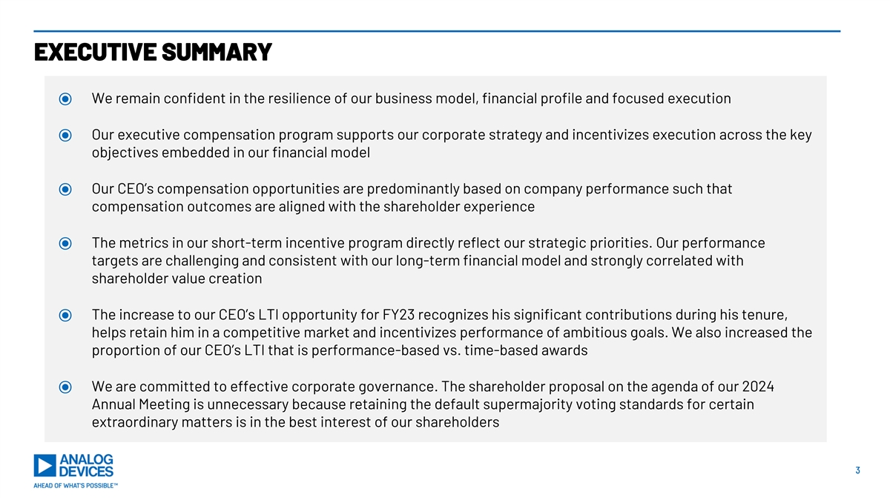
EXECUTIVE SUMMARY ⦿ We remain confident in the resilience of our business model, financial profile and focused execution ⦿ Our executive compensation program supports our corporate strategy and incentivizes execution across the key objectives embedded in our financial model ⦿ Our CEO’s compensation opportunities are predominantly based on company performance such that compensation outcomes are aligned with the shareholder experience ⦿ The metrics in our short-term incentive program directly reflect our strategic priorities. Our performance targets are challenging and consistent with our long-term financial model and strongly correlated with shareholder value creation ⦿ The increase to our CEO’s LTI opportunity for FY23 recognizes his significant contributions during his tenure, helps retain him in a competitive market and incentivizes performance of ambitious goals. We also increased the proportion of our CEO’s LTI that is performance-based vs. time-based awards ⦿ We are committed to effective corporate governance. The shareholder proposal on the agenda of our 2024 Annual Meeting is unnecessary because retaining the default supermajority voting standards for certain extraordinary matters is in the best interest of our shareholders 3

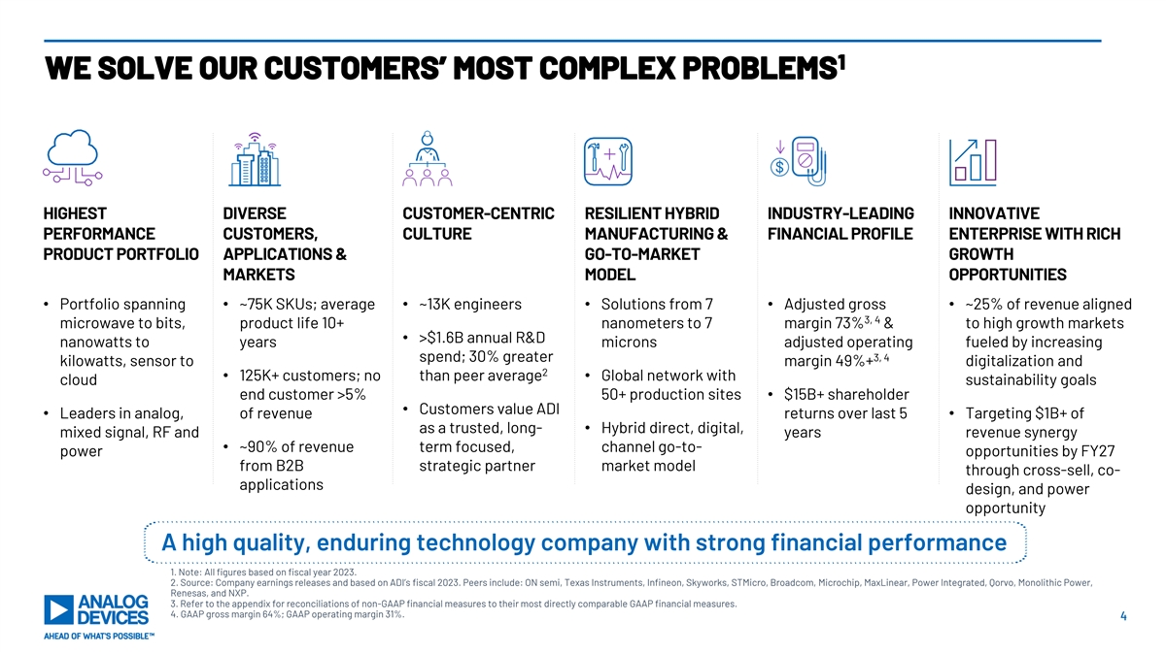
1 WE SOLVE OUR CUSTOMERS’ MOST COMPLEX PROBLEMS HIGHEST DIVERSE CUSTOMER-CENTRIC RESILIENT HYBRID INDUSTRY-LEADING INNOVATIVE PERFORMANCE CUSTOMERS, CULTURE MANUFACTURING & FINANCIAL PROFILE ENTERPRISE WITH RICH PRODUCT PORTFOLIO APPLICATIONS & GO-TO-MARKET GROWTH MARKETS MODEL OPPORTUNITIES • Portfolio spanning • ~75K SKUs; average • ~13K engineers• Solutions from 7 • Adjusted gross • ~25% of revenue aligned 3, 4 microwave to bits, product life 10+ nanometers to 7 margin 73% & to high growth markets • >$1.6B annual R&D nanowatts to years microns adjusted operating fueled by increasing spend; 30% greater 3, 4 kilowatts, sensor to margin 49%+ digitalization and 2 • 125K+ customers; no than peer average• Global network with cloud sustainability goals end customer >5% 50+ production sites• $15B+ shareholder • Customers value ADI • Leaders in analog, of revenue returns over last 5 • Targeting $1B+ of as a trusted, long-• Hybrid direct, digital, mixed signal, RF and years revenue synergy • ~90% of revenue term focused, channel go-to- power opportunities by FY27 from B2B strategic partner market model through cross-sell, co- applications design, and power opportunity A high quality, enduring technology company with strong financial performance 1. Note: All figures based on fiscal year 2023. 2. Source: Company earnings releases and based on ADI’s fiscal 2023. Peers include: ON semi, Texas Instruments, Infineon, Skyworks, STMicro, Broadcom, Microchip, MaxLinear, Power Integrated, Qorvo, Monolithic Power, Renesas, and NXP. 3. Refer to the appendix for reconciliations of non-GAAP financial measures to their most directly comparable GAAP financial measures. 4. GAAP gross margin 64%; GAAP operating margin 31%. 4

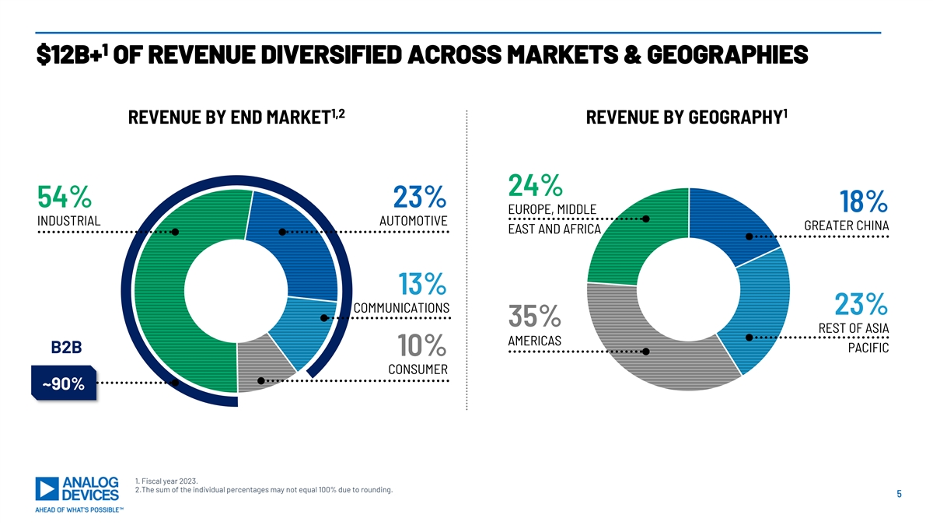
1 $12B+ OF REVENUE DIVERSIFIED ACROSS MARKETS & GEOGRAPHIES 1,2 1 REVENUE BY END MARKET REVENUE BY GEOGRAPHY 24% 54% 23% 18% EUROPE, MIDDLE INDUSTRIAL AUTOMOTIVE GREATER CHINA EAST AND AFRICA 13% COMMUNICATIONS 23% 35% REST OF ASIA AMERICAS B2B PACIFIC 10% CONSUMER ~90% 1. Fiscal year 2023. 2.The sum of the individual percentages may not equal 100% due to rounding. 5

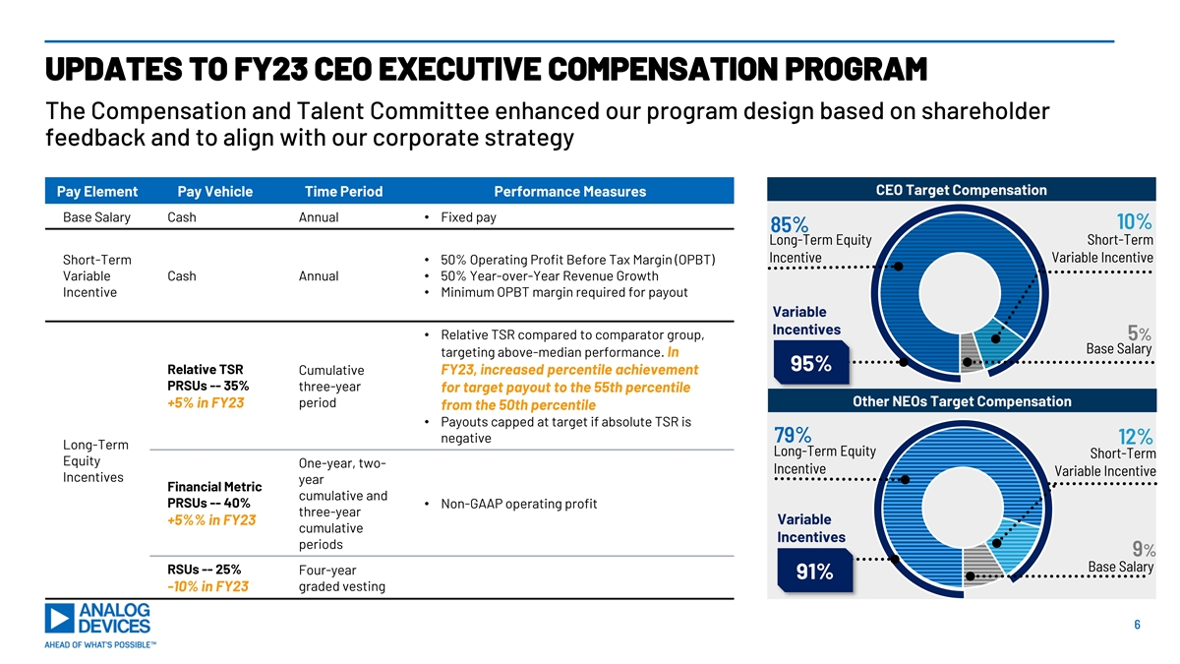
UPDATES TO FY23 CEO EXECUTIVE COMPENSATION PROGRAM The Compensation and Talent Committee enhanced our program design based on shareholder feedback and to align with our corporate strategy CEO Target Compensation Pay Element Pay Vehicle Time Period Performance Measures Base Salary Cash Annual• Fixed pay 10% 85% Long-Term Equity Short-Term Incentive Variable Incentive Short-Term • 50% Operating Profit Before Tax Margin (OPBT) Variable Cash Annual • 50% Year-over-Year Revenue Growth Incentive• Minimum OPBT margin required for payout Variable Incentives • Relative TSR compared to comparator group, 5% Base Salary targeting above-median performance. In 95% Relative TSR Cumulative FY23, increased percentile achievement PRSUs -- 35% three-year for target payout to the 55th percentile period Other NEOs Target Compensation +5% in FY23 from the 50th percentile • Payouts capped at target if absolute TSR is negative 79% 12% Long-Term Long-Term Equity Short-Term Equity One-year, two- Incentive Variable Incentive Incentives year Financial Metric cumulative and PRSUs -- 40% • Non-GAAP operating profit three-year +5%% in FY23 Variable cumulative Incentives periods 9% Base Salary RSUs -- 25% Four-year 91% -10% in FY23 graded vesting 6

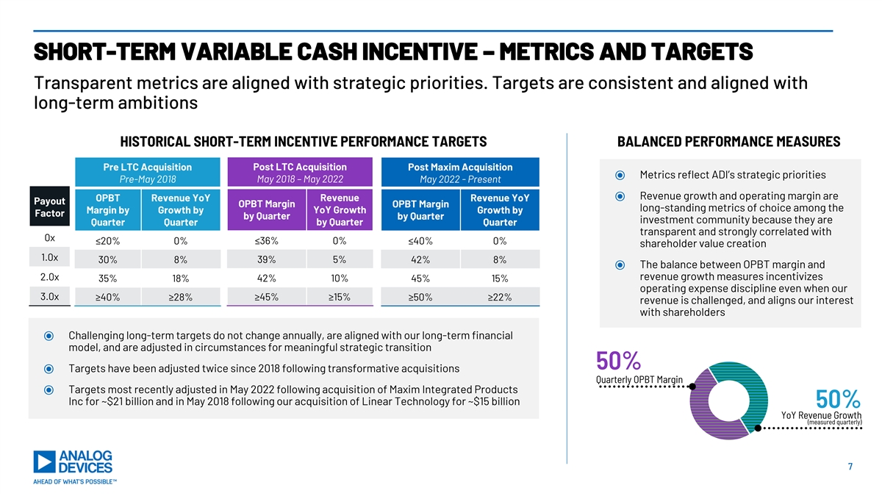
SHORT-TERM VARIABLE CASH INCENTIVE – METRICS AND TARGETS Transparent metrics are aligned with strategic priorities. Targets are consistent and aligned with long-term ambitions HISTORICAL SHORT-TERM INCENTIVE PERFORMANCE TARGETS BALANCED PERFORMANCE MEASURES Pre LTC Acquisition Post LTC Acquisition Post Maxim Acquisition ⦿ Metrics reflect ADI’s strategic priorities Pre-May 2018 May 2018 – May 2022 May 2022 - Present ⦿ Revenue growth and operating margin are OPBT Revenue YoY Revenue Revenue YoY Payout OPBT Margin OPBT Margin long-standing metrics of choice among the YoY Growth Margin by Growth by Growth by Factor by Quarter by Quarter investment community because they are Quarter Quarter by Quarter Quarter transparent and strongly correlated with 0x ≤20% 0% ≤36% 0% ≤40% 0% shareholder value creation 1.0x 39% 5% 30% 8% 42% 8% ⦿ The balance between OPBT margin and 2.0x revenue growth measures incentivizes 35% 18% 42% 10% 45% 15% operating expense discipline even when our 3.0x ≥40% ≥28% ≥45% ≥15% ≥50% ≥22% revenue is challenged, and aligns our interest with shareholders ⦿ Challenging long-term targets do not change annually, are aligned with our long-term financial model, and are adjusted in circumstances for meaningful strategic transition 50% ⦿ Targets have been adjusted twice since 2018 following transformative acquisitions Quarterly OPBT Margin ⦿ Targets most recently adjusted in May 2022 following acquisition of Maxim Integrated Products Inc for ~$21 billion and in May 2018 following our acquisition of Linear Technology for ~$15 billion 50% YoY Revenue Growth (measured quarterly) 7

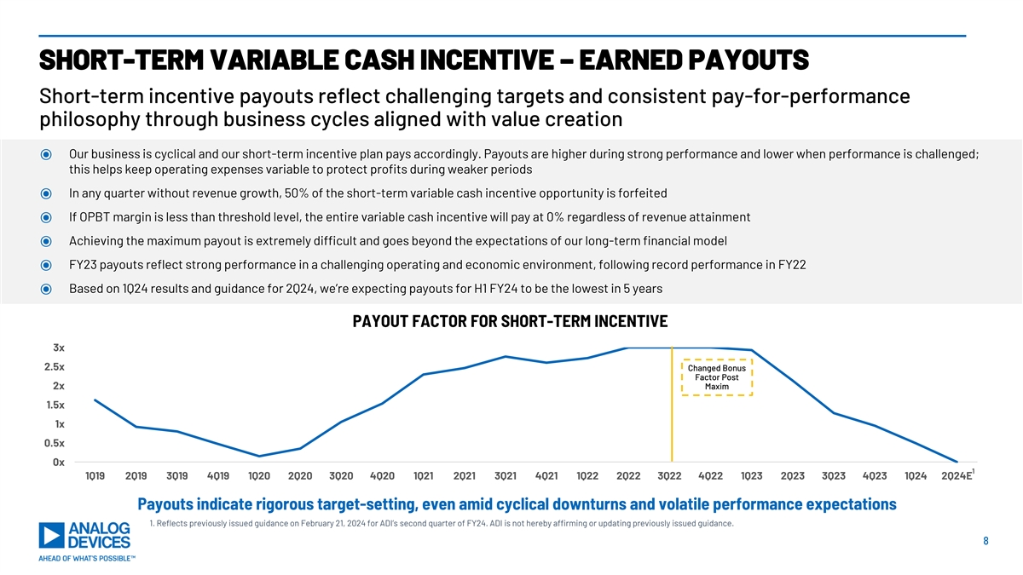
SHORT-TERM VARIABLE CASH INCENTIVE – EARNED PAYOUTS Short-term incentive payouts reflect challenging targets and consistent pay-for-performance philosophy through business cycles aligned with value creation ⦿ Our business is cyclical and our short-term incentive plan pays accordingly. Payouts are higher during strong performance and lower when performance is challenged; this helps keep operating expenses variable to protect profits during weaker periods ⦿ In any quarter without revenue growth, 50% of the short-term variable cash incentive opportunity is forfeited ⦿ If OPBT margin is less than threshold level, the entire variable cash incentive will pay at 0% regardless of revenue attainment ⦿ Achieving the maximum payout is extremely difficult and goes beyond the expectations of our long-term financial model ⦿ FY23 payouts reflect strong performance in a challenging operating and economic environment, following record performance in FY22 ⦿ Based on 1Q24 results and guidance for 2Q24, we’re expecting payouts for H1 FY24 to be the lowest in 5 years PAYOUT FACTOR FOR SHORT-TERM INCENTIVE 3x 2.5x Changed Bonus Factor Post 2x Maxim 1.5x 1x 0.5x 0x 1 1Q19 2Q19 3Q19 4Q19 1Q20 2Q20 3Q20 4Q20 1Q21 2Q21 3Q21 4Q21 1Q22 2Q22 3Q22 4Q22 1Q23 2Q23 3Q23 4Q23 1Q24 2Q24E Payouts indicate rigorous target-setting, even amid cyclical downturns and volatile performance expectations 1. Reflects previously issued guidance on February 21, 2024 for ADI’s second quarter of FY24. ADI is not hereby affirming or updating previously issued guidance. 8

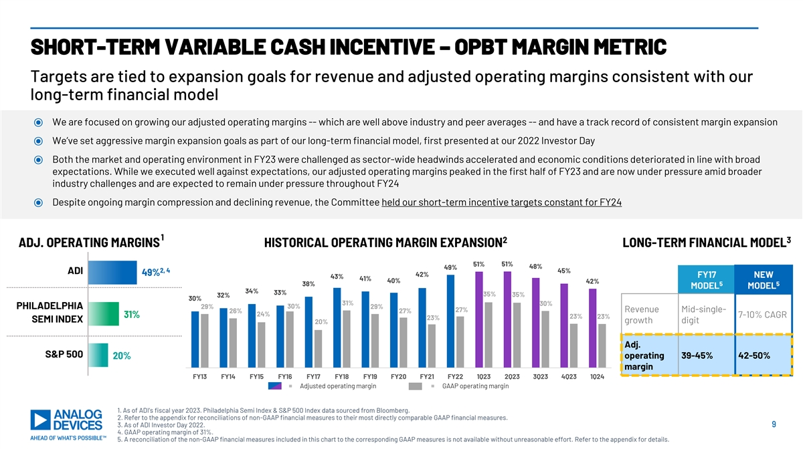
SHORT-TERM VARIABLE CASH INCENTIVE – OPBT MARGIN METRIC Targets are tied to expansion goals for revenue and adjusted operating margins consistent with our long-term financial model ⦿ We are focused on growing our adjusted operating margins -- which are well above industry and peer averages -- and have a track record of consistent margin expansion ⦿ We’ve set aggressive margin expansion goals as part of our long-term financial model, first presented at our 2022 Investor Day ⦿ Both the market and operating environment in FY23 were challenged as sector-wide headwinds accelerated and economic conditions deteriorated in line with broad expectations. While we executed well against expectations, our adjusted operating margins peaked in the first half of FY23 and are now under pressure amid broader industry challenges and are expected to remain under pressure throughout FY24 ⦿ Despite ongoing margin compression and declining revenue, the Committee held our short-term incentive targets constant for FY24 1 2 3 ADJ. OPERATING MARGINS HISTORICAL OPERATING MARGIN EXPANSION LONG-TERM FINANCIAL MODEL 51% 51% 48% 49% 2, 4 45% ADI 49% 42% FY17 NEW 43% 41% 40% 42% 38% 5 5 MODEL MODEL 34% 33% 35% 32% 35% 30% 31% 30% PHILADELPHIA 29% 30% 29% 27% Revenue Mid-single- 26% 27% 24% 31% 7-10% CAGR 23% 23% 23% SEMI INDEX growth digit 20% Adj. S&P 500 20% operating 39-45% 42-50% margin FY13 FY14 FY15 FY16 FY17 FY18 FY19 FY20 FY21 FY22 1Q23 2Q23 3Q23 4Q23 1Q24 = Adjusted operating margin = GAAP operating margin 1. As of ADI’s fiscal year 2023. Philadelphia Semi Index & S&P 500 Index data sourced from Bloomberg. 2. Refer to the appendix for reconciliations of non-GAAP financial measures to their most directly comparable GAAP financial measures. 3. As of ADI Investor Day 2022. 9 4. GAAP operating margin of 31%. 5. A reconciliation of the non-GAAP financial measures included in this chart to the corresponding GAAP measures is not available without unreasonable effort. Refer to the appendix for details.

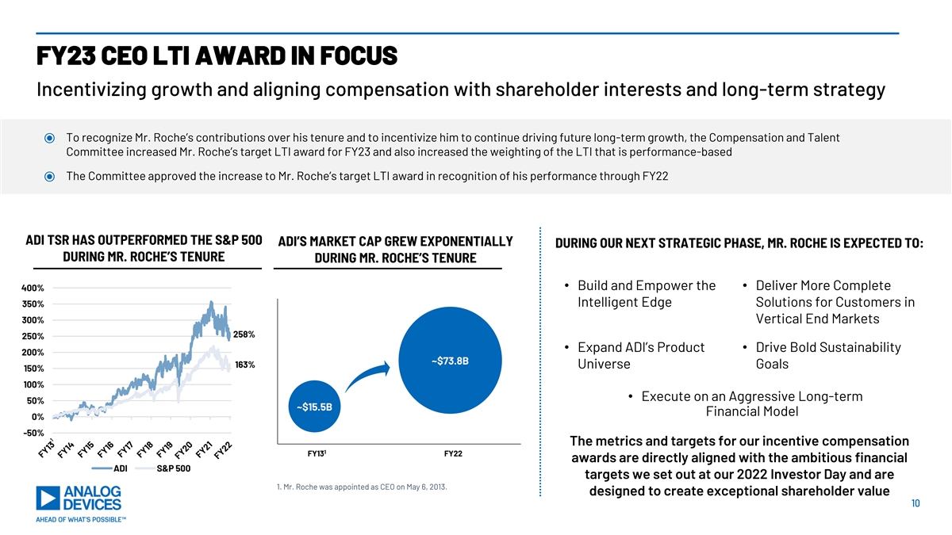
FY23 CEO LTI AWARD IN FOCUS Incentivizing growth and aligning compensation with shareholder interests and long-term strategy ⦿ To recognize Mr. Roche’s contributions over his tenure and to incentivize him to continue driving future long-term growth, the Compensation and Talent Committee increased Mr. Roche’s target LTI award for FY23 and also increased the weighting of the LTI that is performance-based ⦿ The Committee approved the increase to Mr. Roche’s target LTI award in recognition of his performance through FY22 ADI TSR HAS OUTPERFORMED THE S&P 500 ADI’S MARKET CAP GREW EXPONENTIALLY DURING OUR NEXT STRATEGIC PHASE, MR. ROCHE IS EXPECTED TO: DURING MR. ROCHE’S TENURE DURING MR. ROCHE’S TENURE • Build and Empower the • Deliver More Complete 400% 350% Intelligent Edge Solutions for Customers in 300% Vertical End Markets 258% 250% • Expand ADI’s Product • Drive Bold Sustainability 200% ~$73.8B 163% Universe Goals 150% 100% • Execute on an Aggressive Long-term 50% ~$15.5B Financial Model 0% -50% The metrics and targets for our incentive compensation 1 FY13 FY22 awards are directly aligned with the ambitious financial ADI S&P 500 targets we set out at our 2022 Investor Day and are 1. Mr. Roche was appointed as CEO on May 6, 2013. designed to create exceptional shareholder value 10

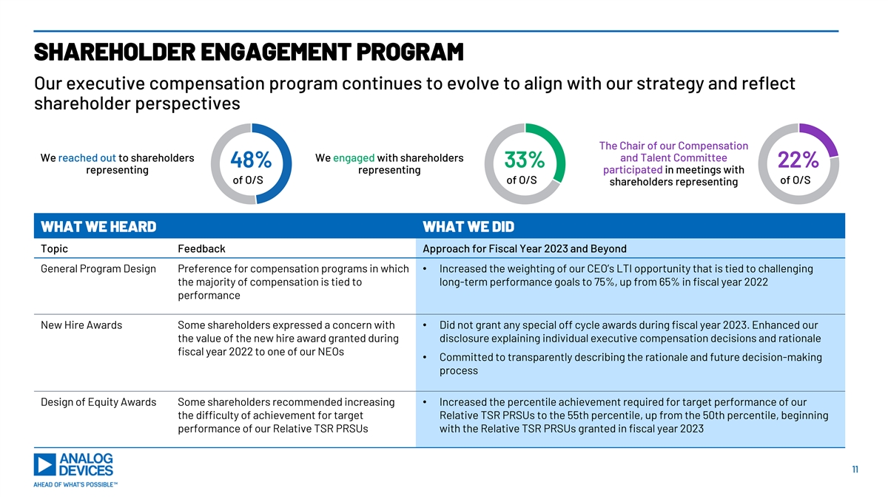
SHAREHOLDER ENGAGEMENT PROGRAM Our executive compensation program continues to evolve to align with our strategy and reflect shareholder perspectives The Chair of our Compensation We reached out to shareholders We engaged with shareholders and Talent Committee 48% 33% 22% representing representing participated in meetings with of O/S of O/S of O/S shareholders representing WHAT WE HEARD WHAT WE DID Topic Feedback Approach for Fiscal Year 2023 and Beyond General Program Design Preference for compensation programs in which • Increased the weighting of our CEO’s LTI opportunity that is tied to challenging the majority of compensation is tied to long-term performance goals to 75%, up from 65% in fiscal year 2022 performance New Hire Awards Some shareholders expressed a concern with • Did not grant any special off cycle awards during fiscal year 2023. Enhanced our the value of the new hire award granted during disclosure explaining individual executive compensation decisions and rationale fiscal year 2022 to one of our NEOs • Committed to transparently describing the rationale and future decision-making process Design of Equity Awards Some shareholders recommended increasing • Increased the percentile achievement required for target performance of our the difficulty of achievement for target Relative TSR PRSUs to the 55th percentile, up from the 50th percentile, beginning performance of our Relative TSR PRSUs with the Relative TSR PRSUs granted in fiscal year 2023 11

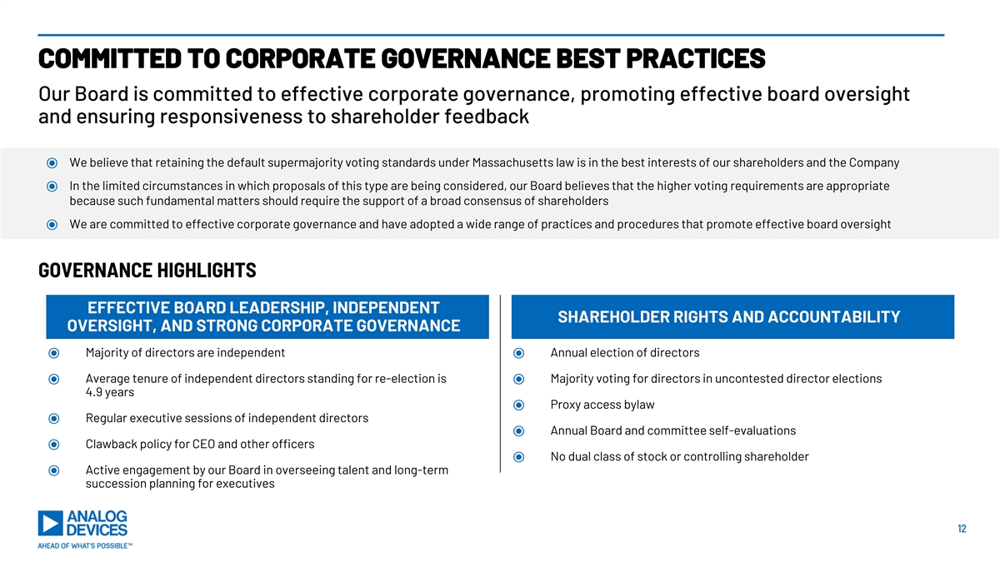
COMMITTED TO CORPORATE GOVERNANCE BEST PRACTICES Our Board is committed to effective corporate governance, promoting effective board oversight and ensuring responsiveness to shareholder feedback ⦿ We believe that retaining the default supermajority voting standards under Massachusetts law is in the best interests of our shareholders and the Company ⦿ In the limited circumstances in which proposals of this type are being considered, our Board believes that the higher voting requirements are appropriate because such fundamental matters should require the support of a broad consensus of shareholders ⦿ We are committed to effective corporate governance and have adopted a wide range of practices and procedures that promote effective board oversight GOVERNANCE HIGHLIGHTS EFFECTIVE BOARD LEADERSHIP, INDEPENDENT SHAREHOLDER RIGHTS AND ACCOUNTABILITY OVERSIGHT, AND STRONG CORPORATE GOVERNANCE ⦿ Majority of directors are independent⦿ Annual election of directors ⦿ Average tenure of independent directors standing for re-election is ⦿ Majority voting for directors in uncontested director elections 4.9 years ⦿ Proxy access bylaw ⦿ Regular executive sessions of independent directors ⦿ Annual Board and committee self-evaluations ⦿ Clawback policy for CEO and other officers ⦿ No dual class of stock or controlling shareholder ⦿ Active engagement by our Board in overseeing talent and long-term succession planning for executives 12

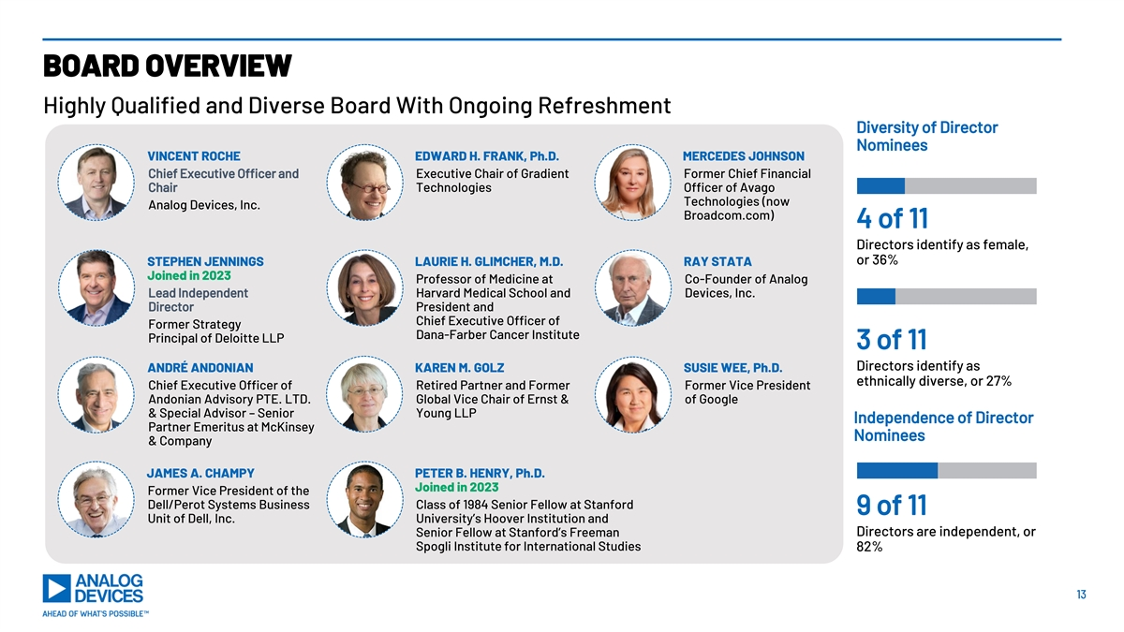
LEADERSHIP BOARD OVERVIEW Highly Qualified and Diverse Board With Ongoing Refreshment Diversity of Director Nominees VINCENT ROCHE EDWARD H. FRANK, Ph.D. MERCEDES JOHNSON Chief Executive Officer and Executive Chair of Gradient Former Chief Financial Chair Technologies Officer of Avago Technologies (now Analog Devices, Inc. Broadcom.com) 4 of 11 Directors identify as female, or 36% STEPHEN JENNINGS LAURIE H. GLIMCHER, M.D. RAY STATA Joined in 2023 Professor of Medicine at Co-Founder of Analog Lead Independent Harvard Medical School and Devices, Inc. Director President and Chief Executive Officer of Former Strategy Dana-Farber Cancer Institute Principal of Deloitte LLP 3 of 11 Directors identify as ANDRÉ ANDONIAN KAREN M. GOLZ SUSIE WEE, Ph.D. ethnically diverse, or 27% Chief Executive Officer of Retired Partner and Former Former Vice President Andonian Advisory PTE. LTD. Global Vice Chair of Ernst & of Google & Special Advisor – Senior Young LLP Independence of Director Partner Emeritus at McKinsey Nominees & Company JAMES A. CHAMPY PETER B. HENRY, Ph.D. Joined in 2023 Former Vice President of the Dell/Perot Systems Business Class of 1984 Senior Fellow at Stanford 9 of 11 Unit of Dell, Inc. University’s Hoover Institution and Directors are independent, or Senior Fellow at Stanford’s Freeman Spogli Institute for International Studies 82% 13

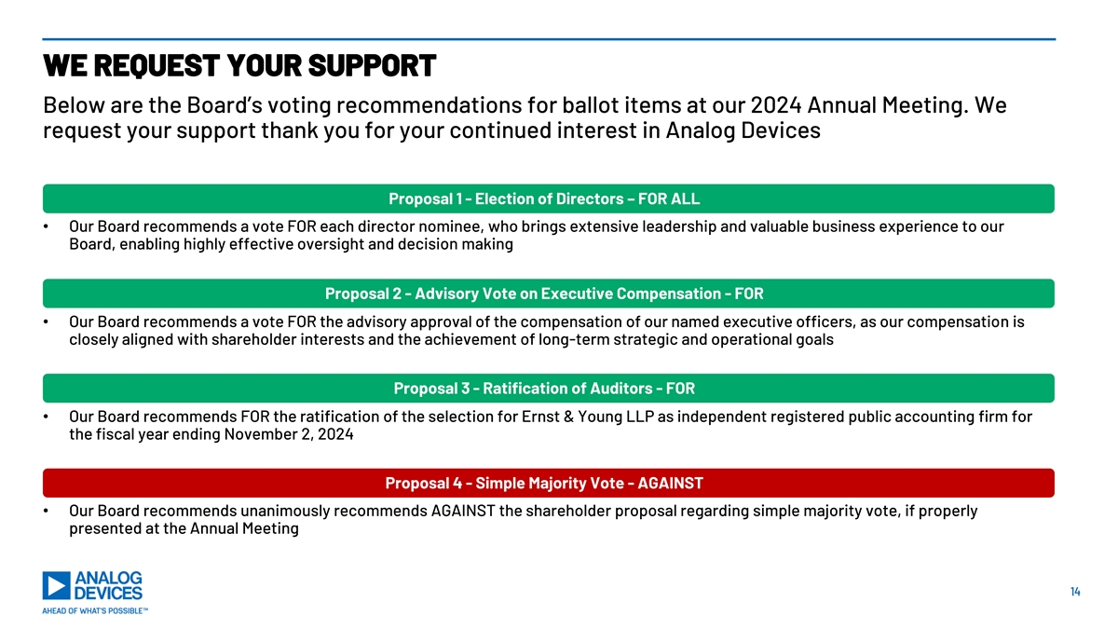
WE REQUEST YOUR SUPPORT Below are the Board’s voting recommendations for ballot items at our 2024 Annual Meeting. We request your support thank you for your continued interest in Analog Devices Proposal 1 - Election of Directors – FOR ALL • Our Board recommends a vote FOR each director nominee, who brings extensive leadership and valuable business experience to our Board, enabling highly effective oversight and decision making Proposal 2 - Advisory Vote on Executive Compensation - FOR • Our Board recommends a vote FOR the advisory approval of the compensation of our named executive officers, as our compensation is closely aligned with shareholder interests and the achievement of long-term strategic and operational goals Proposal 3 - Ratification of Auditors - FOR • Our Board recommends FOR the ratification of the selection for Ernst & Young LLP as independent registered public accounting firm for the fiscal year ending November 2, 2024 Proposal 4 - Simple Majority Vote - AGAINST • Our Board recommends unanimously recommends AGAINST the shareholder proposal regarding simple majority vote, if properly presented at the Annual Meeting 14


APPENDIX

APPENDIX – RECONCILIATION FROM GAAP TO NON-GAAP ($ in millions) The sum and/or computation of the individual amounts may not equal the total due to rounding. 1 FY23 FY23 FY23 Q1 24 Q2 24 (Projected) $2,100 Revenue $12,306 Revenue $12,306 Revenue $12,306 Revenue $2,513 Revenue (+/- $100) Net Cash Provided by GAAP Gross Margin $7,877 GAAP Operating Income $3,823 $4,818 GAAP Operating Income $586 GAAP Operating Income $317 Operating Activities Net Cash Provided by GAAP Gross Margin 15% 64% GAAP Operating Margin 31% Operating Activities % 39% GAAP Operating Margin 23% GAAP Operating Margin % of Revenue (+/- 200 bps) of Revenue Acquisition related Acquisition related Acquisition related Acquisition related $1,047 $2,024 Capital Expenditures $1,261 $452 expenses and special $460 expenses expenses expenses charges, net Adjusted Operating Adjusted Gross Margin $8,925 Special charges, net $161 Free Cash Flow (FCF) $3,556 Special charges, net $16 $777 Income Adjusted Gross Margin Acquisition related Acquisition related Adjusted Operating 37% $7 - 73% % of Revenue 29% 2 transaction costs transaction costs Margin Percentage (+/- 100 bps) Adjusted Operating Adjusted Operating $6,014 $1,054 Income Income Adjusted Operating Adjusted Operating 49% 42% 2 2 Margin Margin 1. Reflects previously issued guidance on February 21, 2024 for ADI’s second quarter of FY24. ADI is not hereby affirming or updating previously issued guidance. 2. Adjusted Operating Margin is equivalent to OPBT margin. 16 16

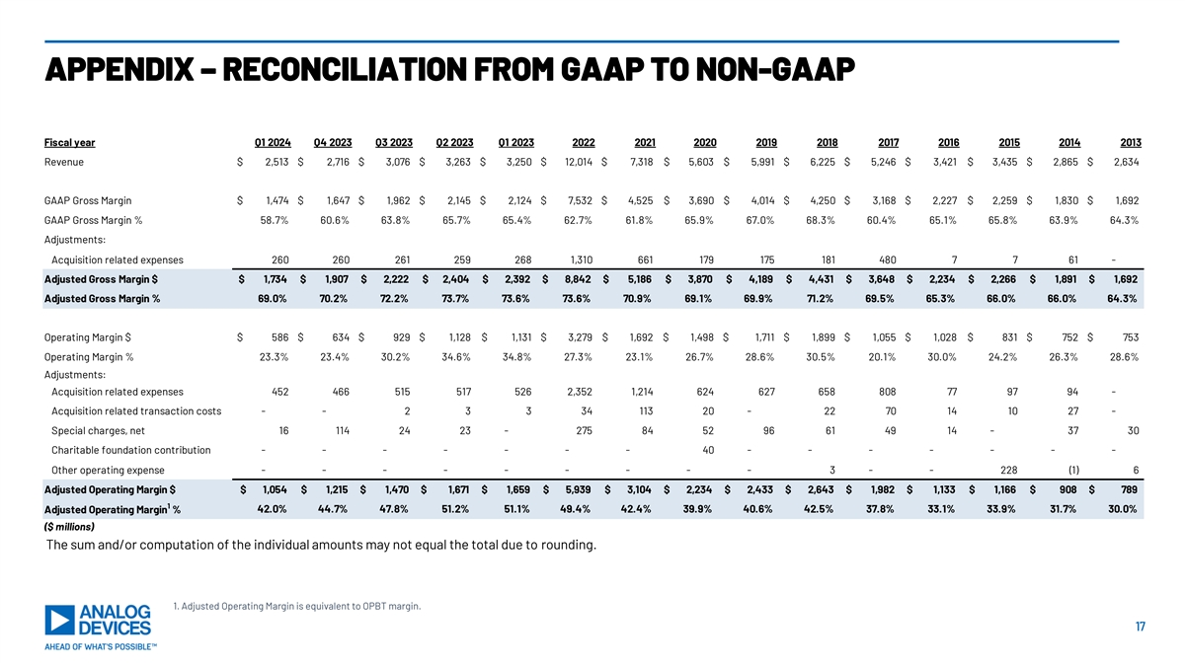
APPENDIX – RECONCILIATION FROM GAAP TO NON-GAAP Fiscal year Q1 2024 Q4 2023 Q3 2023 Q2 2023 Q1 2023 2022 2021 2020 2019 2018 2017 2016 2015 2014 2013 Revenue $ 2,513 $ 2,716 $ 3,076 $ 3,263 $ 3,250 $ 12,014 $ 7,318 $ 5 ,603 $ 5,991 $ 6,225 $ 5,246 $ 3,421 $ 3 ,435 $ 2,865 $ 2,634 GAAP Gross Margin $ 1,474 $ 1,647 $ 1,962 $ 2,145 $ 2,124 $ 7 ,532 $ 4,525 $ 3 ,690 $ 4 ,014 $ 4,250 $ 3,168 $ 2, 227 $ 2, 259 $ 1,830 $ 1,692 GAAP Gross Margin % 58.7% 60.6% 63.8% 65.7% 65.4% 62.7% 61.8% 65.9% 67.0% 68.3% 60.4% 65.1% 65.8% 63.9% 64.3% Adjustments: Acquisition related expenses 260 260 261 259 268 1,310 661 179 175 181 480 7 7 61 - Adjusted Gross Margin $ $ 1,734 $ 1,907 $ 2 ,222 $ 2 ,404 $ 2,392 $ 8,842 $ 5,186 $ 3, 870 $ 4,189 $ 4,431 $ 3,648 $ 2 ,234 $ 2,266 $ 1,891 $ 1,692 Adjusted Gross Margin % 69.0% 70.2% 72.2% 73.7% 73.6% 73.6% 70.9% 69.1% 69.9% 71.2% 69.5% 65.3% 66.0% 66.0% 64.3% Operating Margin $ $ 586 $ 634 $ 929 $ 1 ,128 $ 1,131 $ 3,279 $ 1 ,692 $ 1 ,498 $ 1 ,711 $ 1,899 $ 1,055 $ 1,028 $ 831 $ 752 $ 753 Operating Margin % 23.3% 23.4% 30.2% 34.6% 34.8% 27.3% 23.1% 26.7% 28.6% 30.5% 20.1% 30.0% 24.2% 26.3% 28.6% Adjustments: Acquisition related expenses 452 466 515 517 526 2,352 1,214 624 627 658 808 77 97 94 - Acquisition related transaction costs - - 2 3 3 34 113 20 - 22 70 14 10 27 - Special charges, net 16 114 24 23 - 275 84 52 96 61 49 14 - 37 30 Charitable foundation contribution - - - - - - - 40 - - - - - - - Other operating expense - - - - - - - - - 3 - - 228 (1) 6 Adjusted Operating Margin $ $ 1,054 $ 1,215 $ 1,470 $ 1,671 $ 1 ,659 $ 5,939 $ 3,104 $ 2,234 $ 2,433 $ 2 ,643 $ 1,982 $ 1,133 $ 1,166 $ 9 08 $ 7 89 1 Adjusted Operating Margin % 42.0% 44.7% 47.8% 51.2% 51.1% 49.4% 42.4% 39.9% 40.6% 42.5% 37.8% 33.1% 33.9% 31.7% 30.0% ($ millions) The sum and/or computation of the individual amounts may not equal the total due to rounding. 1. Adjusted Operating Margin is equivalent to OPBT margin. 17 17

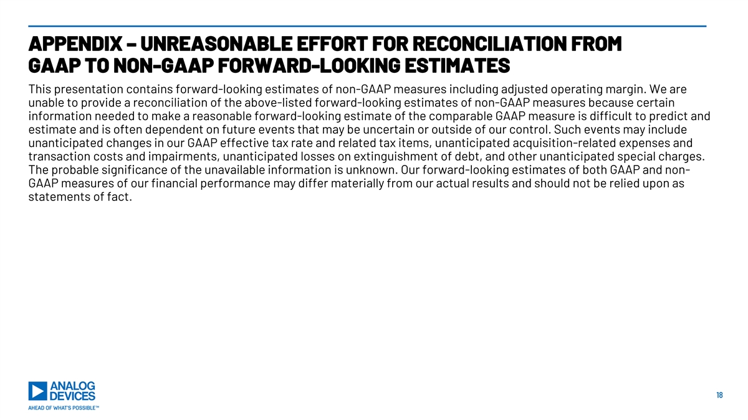
APPENDIX – UNREASONABLE EFFORT FOR RECONCILIATION FROM GAAP TO NON-GAAP FORWARD-LOOKING ESTIMATES This presentation contains forward-looking estimates of non-GAAP measures including adjusted operating margin. We are unable to provide a reconciliation of the above-listed forward-looking estimates of non-GAAP measures because certain information needed to make a reasonable forward-looking estimate of the comparable GAAP measure is difficult to predict and estimate and is often dependent on future events that may be uncertain or outside of our control. Such events may include unanticipated changes in our GAAP effective tax rate and related tax items, unanticipated acquisition-related expenses and transaction costs and impairments, unanticipated losses on extinguishment of debt, and other unanticipated special charges. The probable significance of the unavailable information is unknown. Our forward-looking estimates of both GAAP and non- GAAP measures of our financial performance may differ materially from our actual results and should not be relied upon as statements of fact. 18 18

