UNITED STATES

SECURITIES AND EXCHANGE COMMISSION
WASHINGTON, DC 20549

FORM 8-K

CURRENT REPORT

Pursuant to Section 13 or 15(d)
of the Securities Exchange Act of 1934

Date of Report (Date of earliest event reported): June 9, 2014

Analog Devices, Inc.

(Exact Name of Registrant as Specified in Charter)

Massachusetts

1-7819

04-2348234

(State or Other Jurisdiction
of Incorporation)

(Commission

File Number)

(IRS Employer
Identification No.)

One Technology Way, Norwood, Massachusetts

02062

(Address of Principal Executive Offices)

(Zip Code)

Registrant’s telephone number, including area code: (781) 329-4700

(Former Name or Former Address, if Changed Since Last Report)

Check the appropriate box below if the Form 8-K filing is intended to simultaneously satisfy the filing obligation of the registrant under any of the following provisions (see General Instruction A.2.

below):

- Written communications pursuant to Rule 425 under the Securities Act (17 CFR 230.425)

- Soliciting material pursuant to Rule 14a-12 under the Exchange Act (17 CFR 240.14a-12)

- Pre-commencement communications pursuant to Rule 14d-2(b) under the Exchange Act (17 CFR 240.14d-2(b))

- Pre-commencement communications pursuant to Rule 13e-4(c) under the Exchange Act (17 CFR 240.13e-4(c))

Item 8.01. Other Events.

On June 9, 2014, Analog Devices, Inc. (the “Company”) made available the investor presentation filed as Exhibit 99.1 to this Current Report on Form 8-K, which is incorporated herein by reference.

Item 9.01. Financial Statements and Exhibits.

- Exhibits.

See the Exhibit Index attached to this Current Report on Form 8-K, which is incorporated herein by reference.

Important Additional Information Will Be Filed with the Securities and Exchange Commission

This Current Report on Form 8-K is neither an offer to purchase nor a solicitation of an offer to sell shares of common stock of Hittite Microwave Corporation (“Hittite”). At the time the Company commences its offer to purchase shares of Hittite common stock (the “Offer”), the Company will file with the Securities and Exchange Commission (“SEC”) and mail to Hittite stockholders a Tender Offer Statement and Hittite will file with the SEC and mail to its stockholders a Tender Offer Solicitation/Recommendation Statement in connection with the Offer. These documents will contain important information about the Company, Hittite, the Offer and related matters. Investors and security holders are urged to read each of these documents carefully when they are available. Investors and security holders will be able to obtain free copies of the Tender Offer Statement, the Tender Offer Solicitation/Recommendation Statement and other documents filed with the SEC by the Company and Hittite through the website maintained by the SEC at www.sec.gov. In addition, investors and security holders will be able to obtain free copies of these documents from the Company by contacting the Company’s Director of Investor Relations at Analog Devices, Inc., One Technology Way, Norwood, Massachusetts 02062; telephone: 781-461-3282 or by contacting Hittite’s Chief Financial Officer at Hittite Microwave Corporation, 2 Elizabeth Drive, Chelmsford, Massachusetts 01824; telephone: 978-250-3343.

Forward-Looking Statements

This Current Report on Form 8-K contains forward-looking statements, which address a variety of subjects including, for example, the expected timetable for the closing of the transaction between the Company and Hittite, the expected benefits and synergies of the transaction, including the effect of the transaction on the Company’s non-GAAP earnings, the Company’s expected product development and technical advances resulting from the transaction, the availability of debt financing for the transaction and the Company’s guidance for the remainder of fiscal year 2014. Statements that are not historical facts, including statements about the Company’s beliefs and expectations, are forward-looking statements. Such statements are based on the Company’s current expectations and are subject to a number of factors and uncertainties, which could cause actual results to differ materially from those described in these forward-looking statements. The following important factors and uncertainties, among others, could cause

2

actual results to differ materially from those described in these forward-looking statements: the closing of the transaction is subject to the tender of shares by Hittite stockholders representing at least a majority of the outstanding shares (assuming that shares issuable in respect of vested Hittite restricted stock units and options are outstanding); the receipt of regulatory approvals, and other closing conditions, the non-satisfaction of which may delay or prevent the closing of the transaction; the transaction may involve unexpected costs; the expected benefits of the transaction may not be achieved in a timely manner, or at all; Hittite’s business may not be successfully integrated with the Company’s following the closing; and disruption from the transaction may adversely affect Hittite’s relationships with its customers, suppliers or employees. For additional information about factors that could cause actual results to differ materially from those described in the forward-looking statements, please refer to both the Company’s and Hittite’s filings with the SEC, including the risk factors contained in each of the Company’s and Hittite’s most recent Quarterly Reports on Form 10-Q. Forward-looking statements represent management’s current expectations and are inherently uncertain. Except as required by law, the Company does not undertake any obligation to update forward-looking statements made by it.

3

SIGNATURE

Pursuant to the requirements of the Securities Exchange Act of 1934, the Registrant has duly caused this report to be signed on its behalf by the undersigned hereunto duly authorized.

ANALOG DEVICES, INC.

Date: June 9, 2014 By: /s/ David A. Zinsner

David A. Zinsner

Vice President, Finance and Chief

Financial Officer

4

EXHIBIT INDEX

Exhibit
No. Description

99.1 Investor presentation made available by the Company on June 9, 2014

5

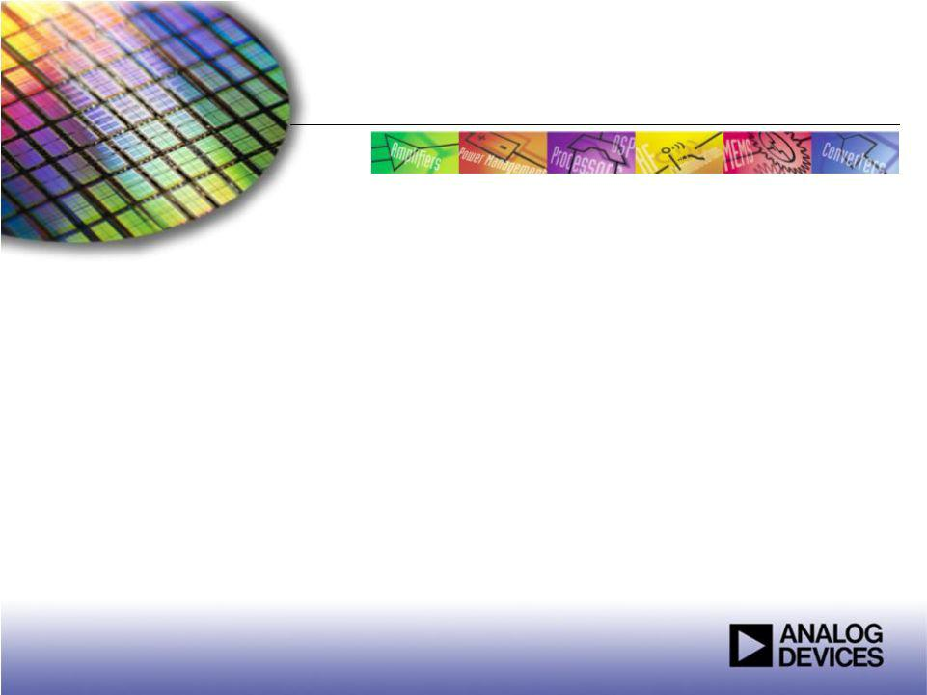
Exhibit 99.1

TheWorldLeaderinHighPerformanceSignalProcessingSolutions

ADI to Acquire Hittite
Microwave Corporation

June 9, 2014


Forward-Looking Statements

This presentation contains forward-looking statements, which address a variety of subjects including, for example, the expected timetable for closing of the transaction between ADI and Hittite Microwave Corporation, the expected benefits and synergies of the transaction,
including the effect of the transaction on ADI’s non-GAAP earnings, ADI’s expected product development and technical advances resulting from the transaction, the availability of debt financing for the transaction and ADI’s guidance for its third and fourth quarters of fiscal year 2014. Statements that are not historical facts, including statements about our beliefs and expectations, are forward-looking statements.

Such statements are based on our current expectations and are subject to a number of factors and uncertainties, which could cause actual results to differ materially from those described in the forward-looking statements. The following important factors and uncertainties, among
others, could cause actual results to differ materially from those described in these forward-looking statements: the closing of the transaction is subject to the tender of shares by Hittite Microwave Corporation stockholders representing at least a majority of the outstanding fully-diluted shares; the receipt of regulatory approvals, and other closing conditions, the non-satisfaction of which may delay or

prevent the closing of the transaction; higher than expected or unexpected costs associated with or relating to the transaction; the expected benefits, synergies and growth prospects of the transaction may not be achieved in a timely manner, or at all; Hittite Microwave

Corporation’s business may not be successfully integrated with ADI’s following the closing; and disruption from the transaction may adversely affect Hittite Microwave Corporation’s relationships with its customers, suppliers or employees. For additional information about

factors that could cause actual results to differ materially from those described in the forward-looking statements, please refer to both ADI’s and Hittite Microwave Corporation’s filings with the Securities and Exchange Commission, including the risk factors contained in each of
ADI’s and Hittite Microwave Corporation’s most recent Quarterly Reports on Form 10-Q. Forward-looking statements represent management’s current expectations and are inherently uncertain. Except as required by law, we do not undertake any obligation to update forward-looking statements made by us to reflect subsequent events or circumstances.

Important Additional Information Will Be Filed with the Securities and Exchange Commission

This presentation is neither an offer to purchase nor a solicitation of an offer to sell shares of Hittite Microwave Corporation. At the time the tender offer is commenced, ADI will file with the Securities and Exchange Commission (“SEC”) and mail to Hittite Microwave Corporation’s stockholders a Tender Offer Statement and Hittite Microwave Corporation will file with the SEC and mail to its stockholders a Tender Offer Solicitation/Recommendation Statement in connection with the transaction. These documents will contain important information about ADI, Hittite Microwave Corporation, the transaction and other related matters. Investors and security holders are urged to read each of these documents carefully when they are available. Investors and security holders will be able to obtain free copies of the Tender Offer Statement, the Tender Offer Solicitation/Recommendation Statement and other documents filed with the SEC by ADI and Hittite Microwave Corporation through the website maintained by the SEC at www.sec.gov. In addition, investors and security holders will be able to obtain free copies of these documents from ADI or Hittite Microwave Corporation by contacting ADI’s Director of Investor Relations at Analog Devices, Inc., One Technology Way, Norwood, Massachusetts 02062; telephone: 781-461-3282 or by contacting Hittite Microwave Corporation’s Chief Financial Officer at Hittite Microwave Corporation, 2 Elizabeth Drive Chelmsford, Massachusetts 01824; telephone:
978-250-3343.

2

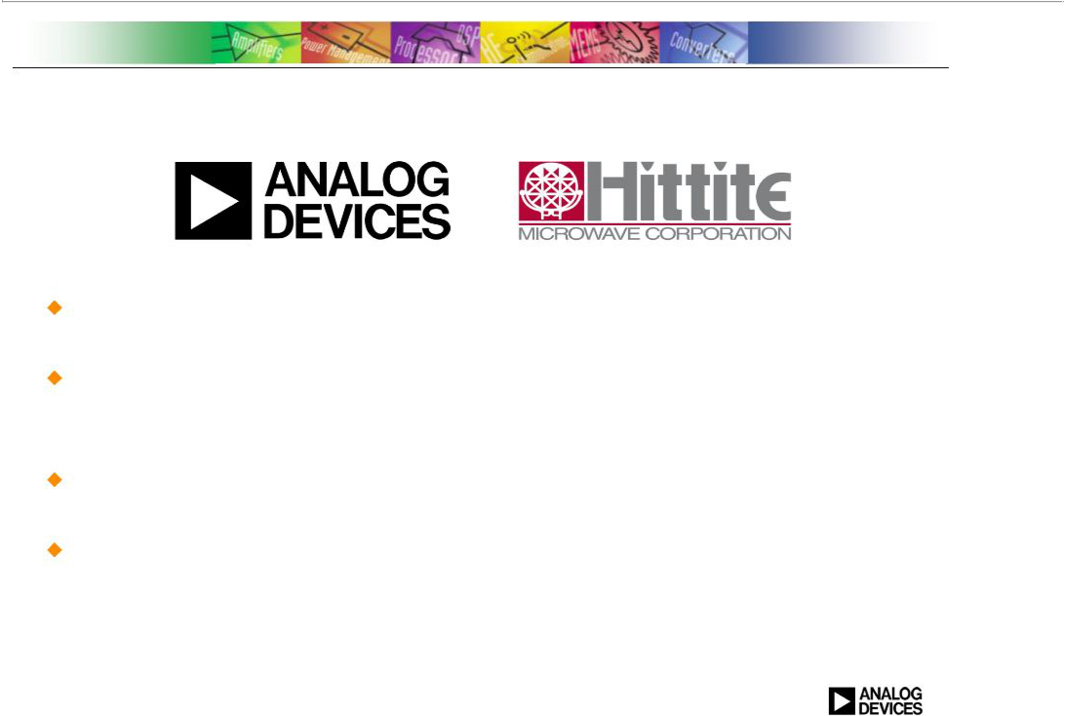
Today’s Announcement

ADI signs definitive agreement to acquire Hittite Microwave Corporation

Offer price for Hittite of $78.00 per share; Enterprise value of approximately $2.0 billion

Expected to be accretive on a non-GAAP basis

Expected to close near the end of ADI’s third fiscal quarter,

subject to regulatory clearance and other customary closing conditions

3

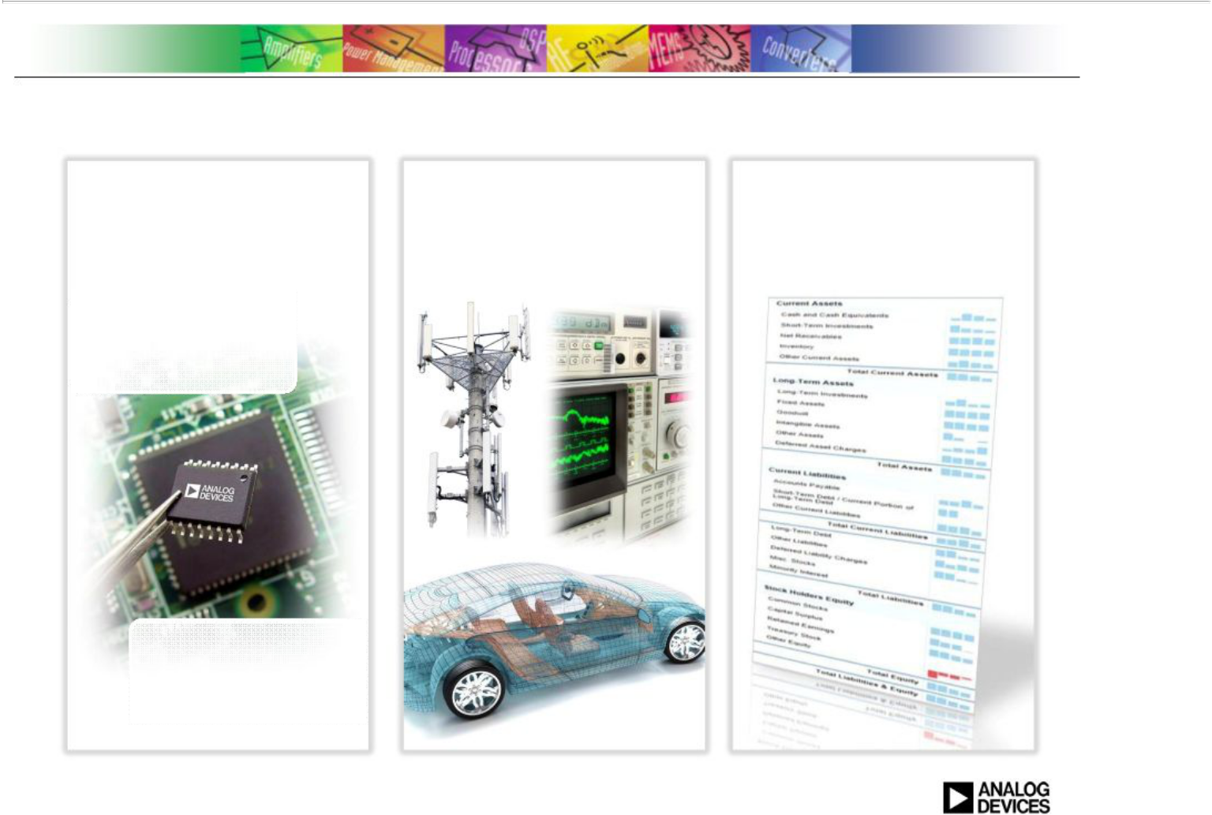
ADI Strategy

Lead in Signal
Processing
Technology

Diversify Across Industrial, Communications & Automotive

Sustain Growth, High Profits & Strong Balance Sheet

Converter

Leader

High Performance
Amplifier

Leader

4

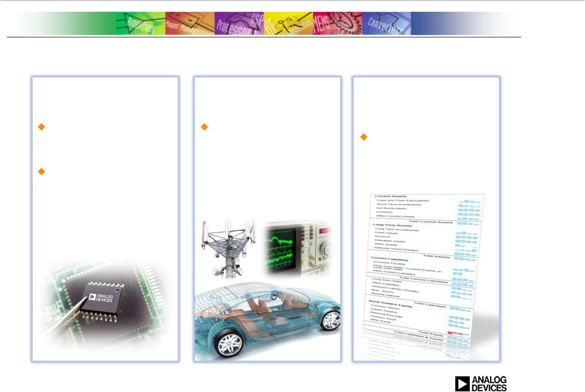
ADI Acquisition of Hittite

Advances Our
Technology Position

Gives ADI the ability to convert the entire frequency spectrum

Strengthens ADI position as a strategic supplier

Expands Our Market | Strengthens ADI’s
Opportunity | Outstanding Financial
Accelerates growth | Performance
Accelerates growth | Expected to be
by expanding market | Expected to be
in ADI’s core | accretive* to gross
businesses of | margins, operating
industrial, comms | profits and EPS
infrastructure, and
automotive

- *On a non-GAAP basis (excluding transaction costs and the amortization of intangibles associated with the transaction)

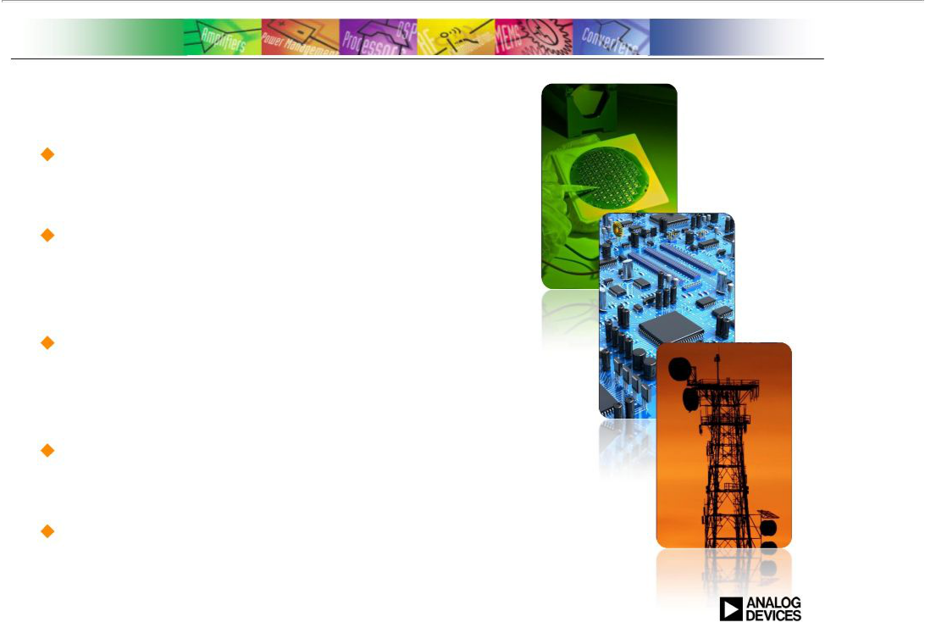
Hittite Overview

Decades long focus in high performance RF and microwave technology

Extensive product portfolio includes
integrated circuits, modules,
and subsystem solutions

Specializes in technically demanding and mission-critical industrial

and communications applications

Fabless business model focuses resources on circuit design and applications engineering

Headquartered in Massachusetts; approximately 500 employees worldwide

6

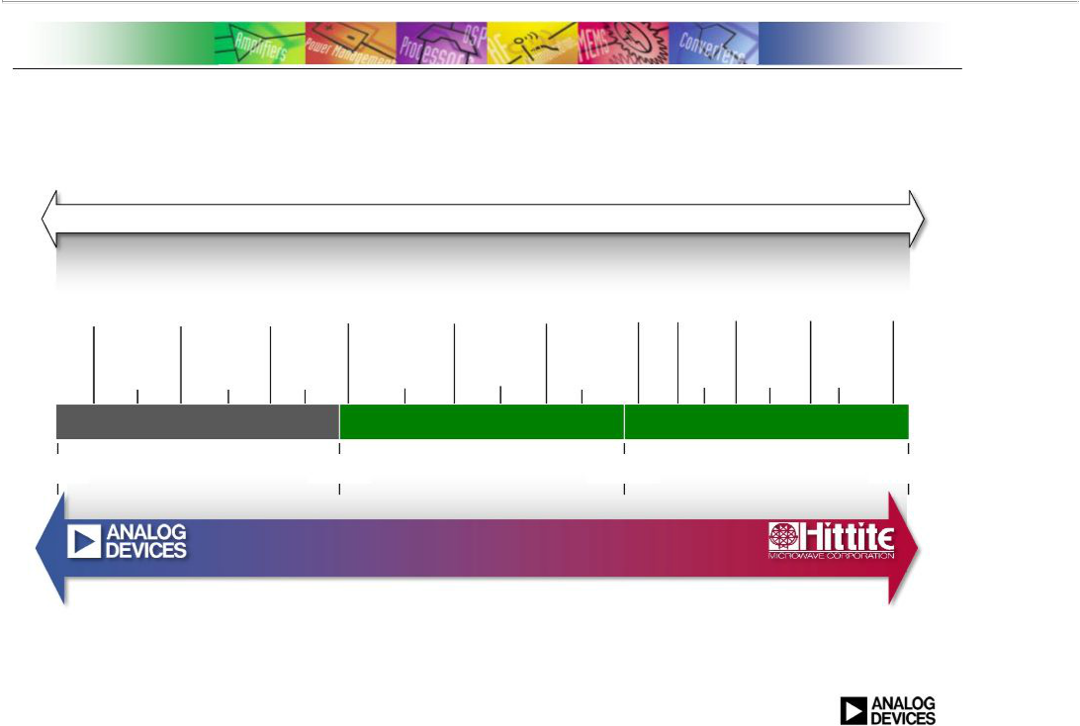
ADI + Hittite

E L E C T R O M A G N E T I C F R E Q U E N C Y S P E C T R U M

24G 77G

Satellite Advanced Military Advanced

Magnetic WiMAX Short Haul Payload Driver Radar & Driver Scientific

Resonance Wireless Data, Cellular Wireless LAN SDH / PDH Comms & Assistance 5G Counter- Assistance Imaging &

Imaging (MRI) Toll Tags 2G, 3G, 4G Access Points Radio Links Telemetry SystemsCommsMeasures Systems Measurement

RFID, DVB,

CATV & Cable Telematics Satellite

Modem GPS Radio

DBS, Consumer

Test Industrial & Industrial

Equipment Imaging VSAT

VBand Eband Pt-to-Pt SATCOM Pt-to-Pt Systems Terminal Systems

Radio Wave

Microwave

Millimeter Wave

0 GHz

6 GHz

20 GHz

110 GHz

C O M B I N E D C A P A B I L I T I E S

7

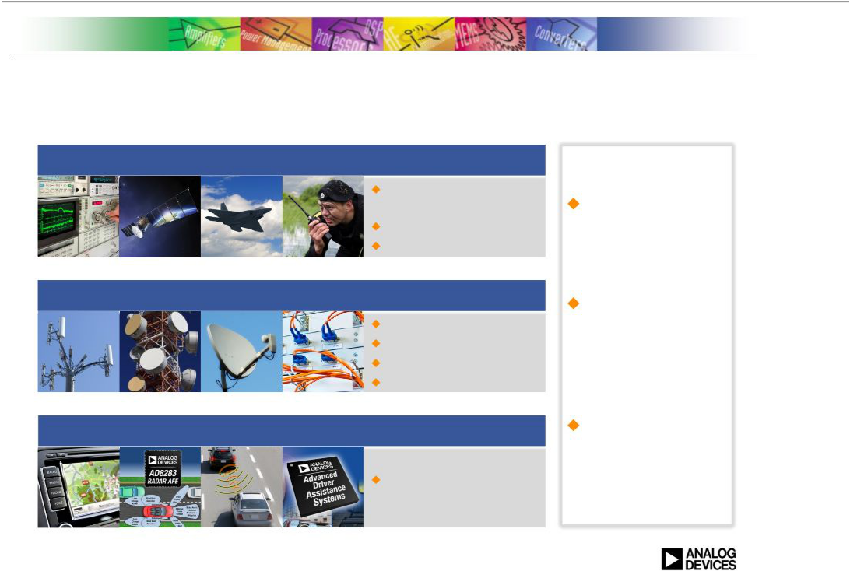
ADI + Hittite

Expands Opportunities within Industrial, Communications, and Automotive

Industrial

Test and

Measurement

Aerospace

Defense

Communications Infrastructure

Cellular infrastructure

Microwave

Broadband

Fiber Optic Networks

Automotive

Advanced Driver

Assistance Systems

Strong
technology
and expertise

Highly
sophisticated
solutions earn
high profits

Expands
addressable
market

8

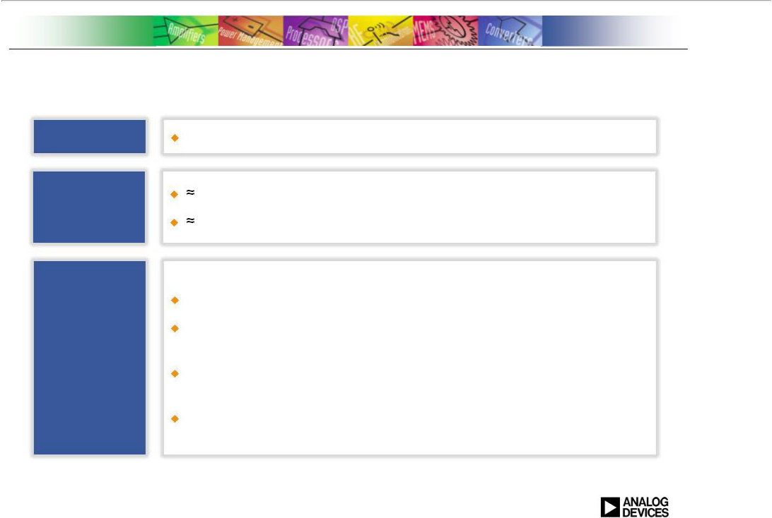
Financial Considerations

Terms

Consideration

Financing

Structure

$78.00 in cash

$2.5 billion equity value

$2.0 enterprise value

Tender offer to be launched in approximately 10 business days

ADI will fund transaction with a combination of cash on hand and short-term debt financing

Continued commitment to returning cash to shareholders through dividends and share repurchases

Ample available liquidity

9

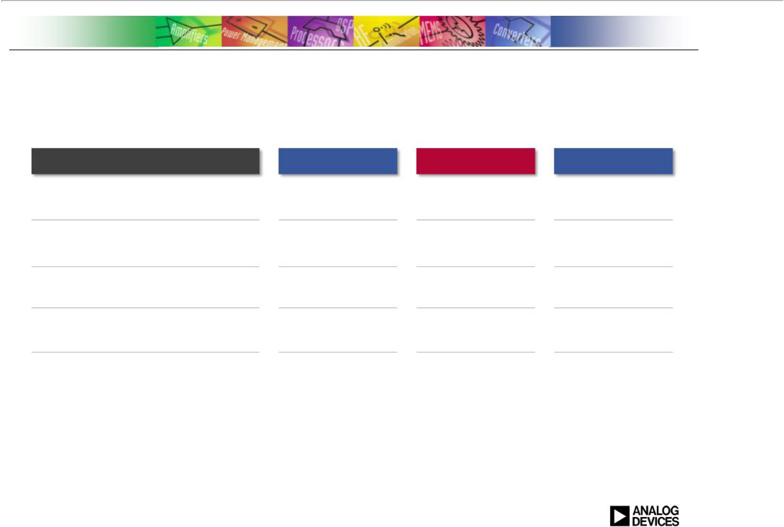
ADI + Hittite

Generating Growth, High Profits & Cash Flow

Key LTM Financial Metrics ⁽¹⁾

Revenue:

Gross profit margin:

Operating margin⁽²⁾:

Cash flow from operations

Cash flow as a % of revenue ⁽³⁾

ADI Hittite

$2,675M $277M

65.3% 69.6%

30.9% 38.1%

$898M $84M

34% 30%

ADI + Hittite

$2,952M

65.7%

31.6%

$982M

33%

(1)
₁₀ (2)

(3)

ADI Last Twelve Months (LTM) ended May 3, 2014 and Hittite LTM ended March 31, 2014

ADI and Hittite operating profits exclude one-time items
Calculated as cash flow from operations divided by revenue

ADI + Hittite

Advances ADI’s Strategy

Adds significant revenue | $M
growth to ADI’s industrial | $1,500
and communications
businesses
Approaching $1B in | $1,000
Amplifier/RF revenue
through expansion into
higher frequency ranges,
especially microwave | $500
Strengthens ADI’s high
performance RF and
microwave expertise | $0
required to address
megatrend of ubiquitous
connectivity

11

Revenue | Revenue
by Market | by Product Category
 | $1,000
+11% | +39%
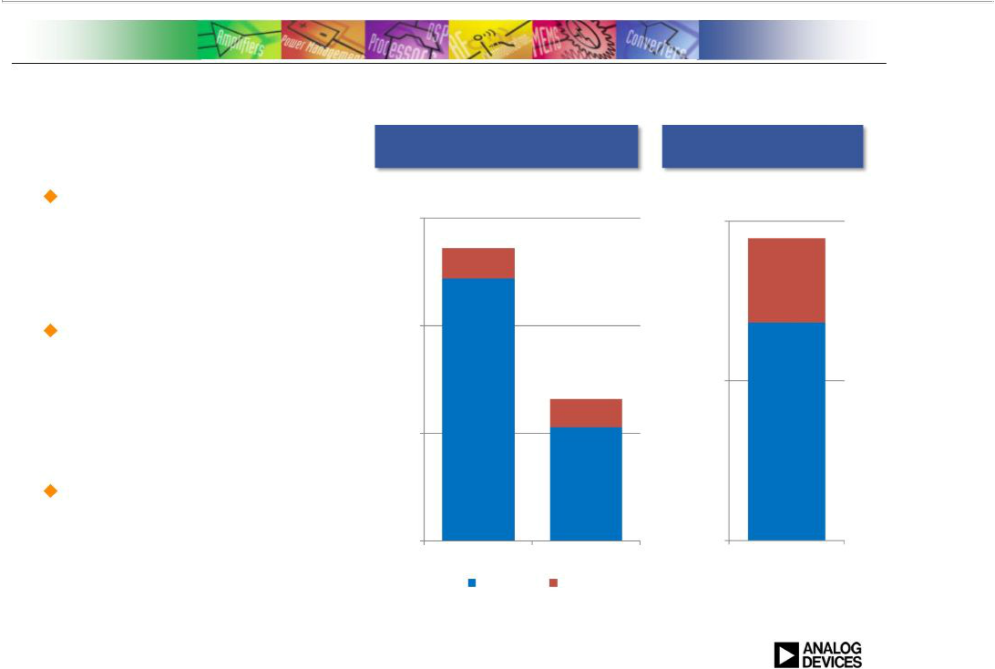

$500

+25%

$0

Industrial Comms Amplifiers/RF

ADI Hittite

Fiscal year 2013

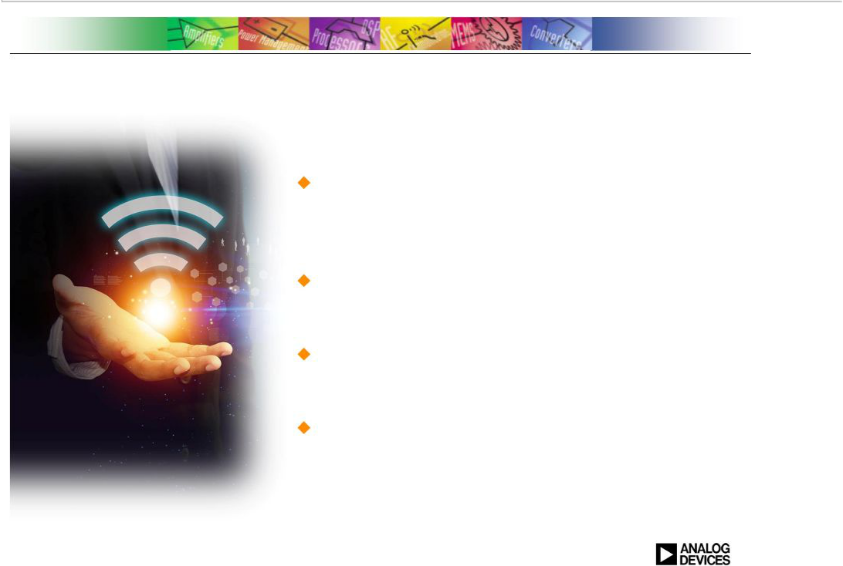
Conclusion

Expands ADI’s Position In High Performance Signal Processing Solutions and drives growth in key markets

Strong complementary position in RF and microwave applications

Allows ADI to provide more complete and differentiated solutions for our customers

Expected to be accretive to margins and EPS on a non-GAAP basis

12


Q&A

13

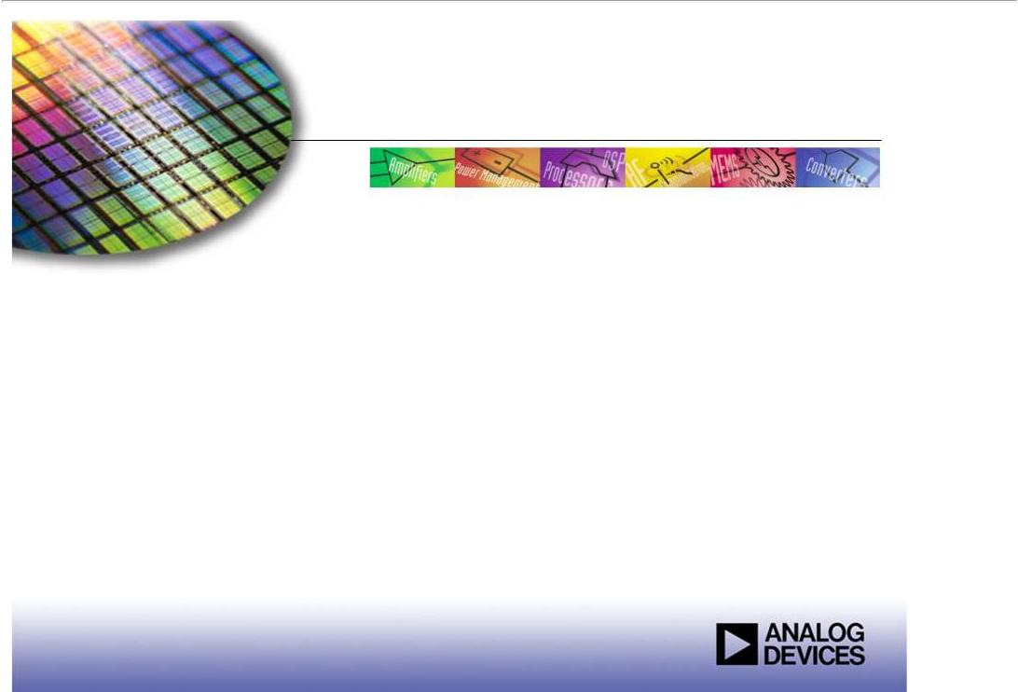
TheWorldLeaderinHighPerformanceSignalProcessingSolutions

Thank You

June 9, 2014


Important Additional Information Will Be Filed with the Securities and Exchange Commission

This presentation is neither an offer to purchase nor a solicitation of an offer to sell shares of Hittite Microwave Corporation. At the time the tender offer is commenced, ADI will file with the Securities and Exchange Commission (“SEC”) and mail to Hittite Microwave Corporation’s stockholders a Tender Offer Statement and Hittite Microwave Corporation will file with the SEC and mail to its stockholders a Tender Offer Solicitation/Recommendation Statement in connection with the transaction. These documents will contain important information about ADI, Hittite Microwave Corporation, the transaction and other related matters. Investors and security holders are urged to read each of these documents carefully when they are available. Investors and security holders will be able to obtain free copies of the Tender Offer Statement, the Tender Offer Solicitation/Recommendation Statement and other documents filed with the SEC by ADI and Hittite Microwave Corporation through the website maintained by the SEC at www.sec.gov. In addition, investors and security holders will be able to obtain free copies of these documents from ADI or Hittite Microwave Corporation by contacting ADI’s Director of Investor Relations at Analog Devices, Inc., One Technology Way, Norwood, Massachusetts 02062; telephone: 781-461-3282 or by contacting Hittite Microwave Corporation’s Chief Financial Officer at Hittite Microwave Corporation, 2 Elizabeth Drive Chelmsford, Massachusetts 01824; telephone: 978-250-3343.

15

