UNITED STATES

SECURITIES AND EXCHANGE COMMISSION
Washington, D.C. 20549

SCHEDULE 14A

(Rule 14a-101)

INFORMATION REQUIRED IN PROXY STATEMENT

SCHEDULE 14A INFORMATION

Proxy Statement Pursuant to Section 14(a) of the

Securities Exchange Act of 1934
(Amendment No. )

Filed by the Registrant ☑

Filed by a Party other than the Registrant ☐

Check the appropriate box:

- Preliminary Proxy Statement

- Confidential, For Use of the Commission Only (as permitted by Rule 14a-6(e)(2))

- Definitive Proxy Statement

- Definitive Additional Materials

- Soliciting Material under § 240.14a-12

Analog Devices, Inc.

(Name of Registrant as Specified in Its Charter)

(Name of Person(s) Filing Proxy Statement, if Other Than the Registrant)

Payment of Filing Fee (Check all boxes that apply):

- No fee required

- Fee paid previously with preliminary materials

- Fee computed on table in exhibit required by Item 25(b) per Exchange Act Rules 14a-6(i)(1) and 0-11

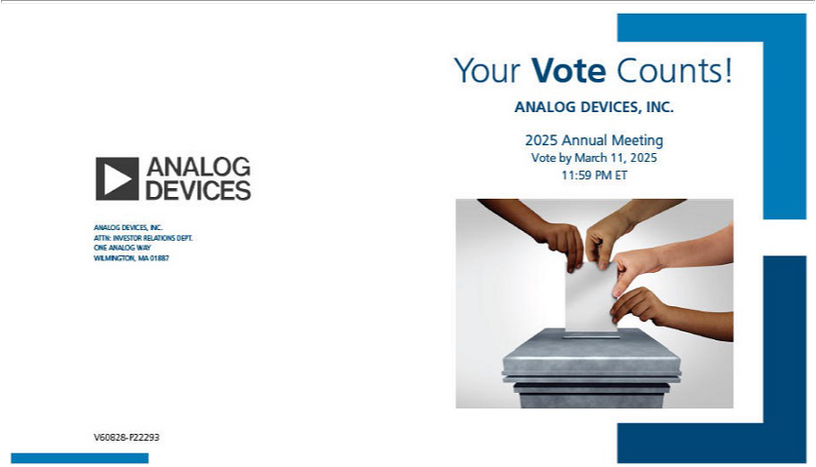

You invested in ANALOG DEVICES, INC. and it’s time to vote!

You have the right to vote on proposals being presented at the Annual Meeting. This is an important notice regarding the availability of proxy materials for the shareholder meeting to be held on March 12, 2025.

Get informed before you vote

View the Notice and Proxy Statement and Annual Report online OR you can receive a free paper or email copy of the material(s) by requesting prior to February 26, 2025. If you would like to request a copy of the material(s) for this and/or future shareholder meetings, you may (1) visit www.ProxyVote.com, (2) call 1-800-579-1639 or (3) send an email to sendmaterial@proxyvote.com. If sending an email, please include your control number (indicated below) in the subject line. Unless requested, you will not otherwise receive a paper or email copy.
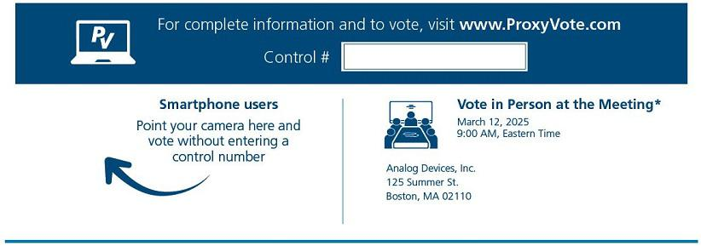

* Please check the meeting materials for any special requirements for meeting attendance. At the meeting, you will need to request a ballot to vote these shares.

Vote at www.ProxyVote.com

THIS IS NOT A VOTABLE BALLOT

This is an overview of the proposals being presented at the

upcoming shareholder meeting. Please follow the instructions
on the reverse side to vote these important matters.

 |  | Board
Voting Items |  | Recommends
1. | The election to Analog Devices’ Board of Directors of the eleven nominees named in our Proxy Statement.
 | Nominees:
1a. | Vincent Roche | For
1b. | Stephen M. Jennings | For
1c. | André Andonian | For
1d. | Edward H. Frank | For
1e. | Laurie H. Glimcher | For
1f. | Karen M. Golz | For
1g. | Peter B. Henry | For
1h. | Mercedes Johnson | For
1i. | Ray Stata | For
1j. | Andrea F. Wainer | For
1k. | Susie Wee | For
2. | Advisory vote to approve the compensation of our named executive officers. | For
3. | Ratification of the selection of Ernst & Young LLP as our independent registered public accounting firm for fiscal year | For
3. | 2025. | For
4. | Approve certain amendments to our Articles of Organization to lower the voting requirement for certain matters from | For
4. | a supermajority to a simple majority standard. | For


NOTE: To transact such other business as may properly come before the meeting and at any adjournments or postponement at the meeting.

Prefer to receive an email instead? While voting on www.ProxyVote.com, be sure to click “Delivery Settings”.

V60829-P22293

